**Bumblebee News**

**__________________________________________________________________________________________________________________________________________________________________________________________**

**Wheeless Road Elementary School Title 1 2530 Wheeless Rd., Augusta, GA**

**706) 796-4985 October 18, 2023 3rd Edition**

**________________________________________________________________________________________________________________________________________________________________________________________________________________________________**

**Principal’s Corner**



Hello Bumblebees,

Let's "Think Pink" for breast cancer awareness month and remember to celebrate National Hispanic Heritage Month! I want to honor our WRES Bumblebee Family cancer survivors and the Bumblebees in memory. The month of October starts the season for us to reflect on the ones we love and the things we have in common. When we all show our bumblebee best, we buzz to excellence! As always, it's spooky to be hungry, and we are one beehive! I hope you enjoyed your Fall Break and are ready to show love and support to all our Wheeless Road families! If you have questions, contact Wheeless Road Elementary School at (706) 796-4985.

Sincerely,

Carl Robinson III, Ed.S.

Principal

Wheeless Road Elementary School

(706) 796-4985 (Work)

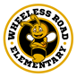

**"Buzzing to Excellence."**

## **Red Ribbon/Bullying Prevention Week**

## RRW THEME 2023 Red Ribbon Week highlights the importance of living a drug-free life. It presents an opportunity for parents, educators, and communities to reinforce the drug-free messages they share with their children throughout the year. During Red Ribbon Week, youth and adults around the nation pledge to increase their knowledge by learning more about the destructive effects of drug abuse, including prescription drug misuse, and renew their commitment to live a healthy, drug-free lifestyle. The 2022 National Red Ribbon Week Theme is **“Be Kind to your Mind. Live Drug Free!”**

**National Bullying Prevention Month** is a time to educate your children about [**anti-bullying**](https://www.twinkl.com/resources/second-grade-usa/social-and-emotional-health-personal-social-health-and-wellness-education-second-grade-usa/bullying-social-and-emotional-health-personal-social-health-and-wellness-education-second-grade-usa). The month raises awareness about the harmful effects that bullying has on kids and adults. The lessons your students will learn during National Bullying Prevention Month about conflict resolution, understanding others, and treating people with kindness will help them in school and beyond. The theme is **“Make A Noise About Bullying.”**

***Upcoming Events***

* ***Red Ribbon/Bullying Prevention Week***

*Monday, October 23 – Friday, October 27*

* ***Fall Semester Progress Report #2***

*Friday, October 27*

* ***Volunteer Training***

*Tuesday, November 7 (8:00 a.m.)*

* ***Veterans Day holiday***

*Friday, November 10*

* ***Thanksgiving holiday***

*Monday, November 20 – Friday, November 24*

We have a week full of activities at WRES to pledge to live a drug-free life and to prevent bullying:

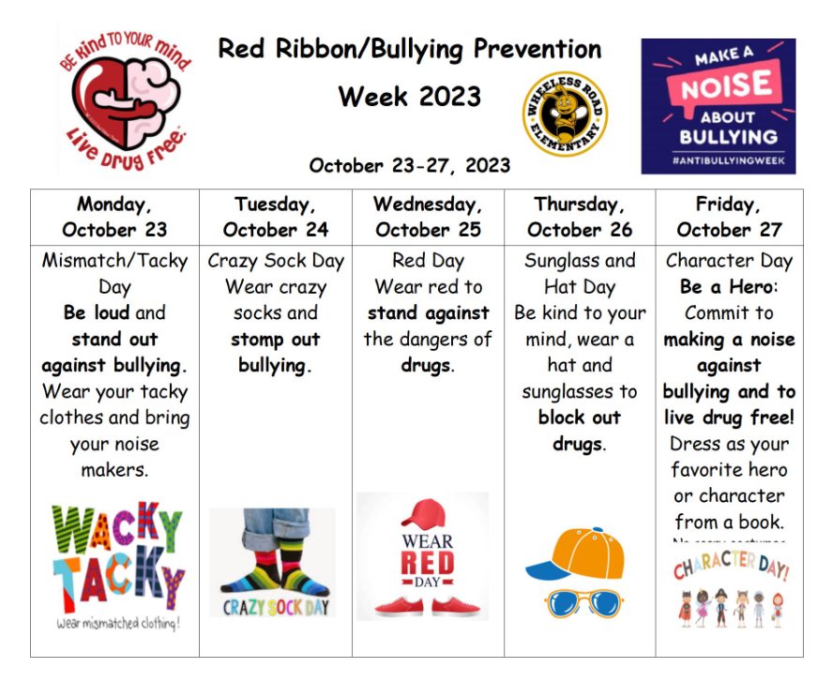

**Character Day (Friday, October 27)**

Dress as your favorite hero or character from a book. You may not wear masks. No scary costumes, please.

**Nov 5, 2023 - Daylight Saving Time Ends**

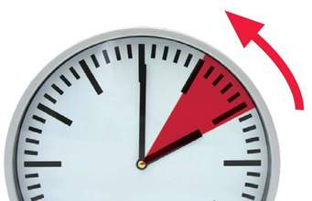 Daylight Saving Time ends on Sunday, November 5, 2023, at 2:00 a.m. At this time, clocks will “fall back” one hour, giving us more daylight in the dark autumn and winter mornings.

**Infinite Campus & Volunteer Training**

**(Tuesday, November 7 – 8:00 a.m.)**

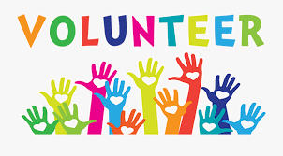 Volunteers may help with classroom activities, field trips, mentoring, office duties, storytelling and tutoring, just to name a few. If you have any questions, please contact Mr. Willis (Parent Facilitator) at (706) 796-4985 ext. 6219.

**Halloween Riddles**

1. **What does a skeleton order for dinner?**
2. **What is a ghost’s favorite dessert?**
3. **Where does a witch park her vehicle?**
4. **What makes a skeleton laugh?**

**Parent Reading Strategies for Students**

* **Predicting –** Look at the book cover together and predict what the book is about.
* **Reread familiar books –** Children need practice in reading comfortably and with expression using books they know.
* **Read together every day –** Spend time talking about stories, pictures, and words.
* **Be a reader and writer –** Children learn habits from the people around them.

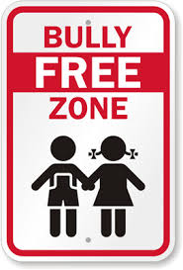**Say NO to bullying! Help make Wheeless Road Elementary a**

Answers to Halloween riddles

1. Spare ribs
2. Ice Scream
3. In the broom closet
4. When something tickles his funny bone